**PORTFOLIO**

ASSIGNMENT OF CSE111

(ORIENTATION TO COMPUTING-1)

**COMPUTER SCIENCE AND ENGINEERING**

Submitted by:

Name: Narasingu Manudeep

Registration number: 12318201

Roll No.: 20

Section: K24DV

**Submitted to :**

**Dr. Abhishek Bhattacherjee**



**LOVELY PROFESSIONAL UNIVERSITY**

**DECLARATION**

I, Narasingu Manudeep, a student of Bachelor of Technology under CSE discipline at Lovely Professional University, Punjab, hereby declare that all the information furnished in this project report is based on my own work and is genuine

Narasingu Manudeep

Registrartion Number: 12318201

|  |  |  |
| --- | --- | --- |
| Platforms for profile creation | Link to student profile | Screenshot |
| ***Figma*** | <https://www.figma.com/design/8HRXG4QzM1RZYu9sT37l1z/Untitled?node-id=0-1&node-type=canvas&t=hrcrZXtnSVeBEfc2-0> | 1 |
| ***Quora*** | <https://www.quora.com/profile/Manu-Deep-34> | 2 |
| ***Stack overflow*** | <https://stackoverflow.com/users/28112643/manudeep-narasingu> | 3 |
| ***Hacker Rank*** | <https://www.hackerrank.com/profile/manudeep1000> | 4 |
| ***Hacker Earth*** | <https://www.hackerearth.com/@manudeep1000/> | 5-6 |
| ***Geeks for Geeks*** | <https://www.geeksforgeeks.org/user/manudee02mz/> | 7 |
| ***Github*** | <https://github.com/manudeep07> | 8 |

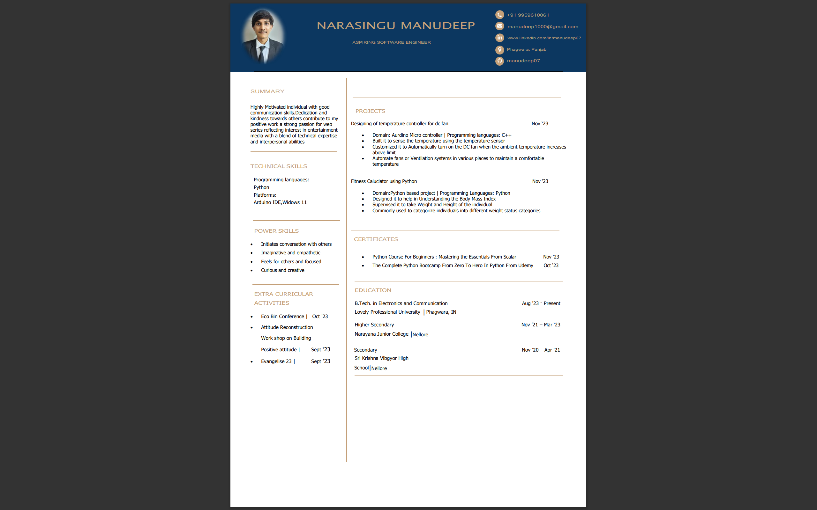**cv**

**GITHUB**

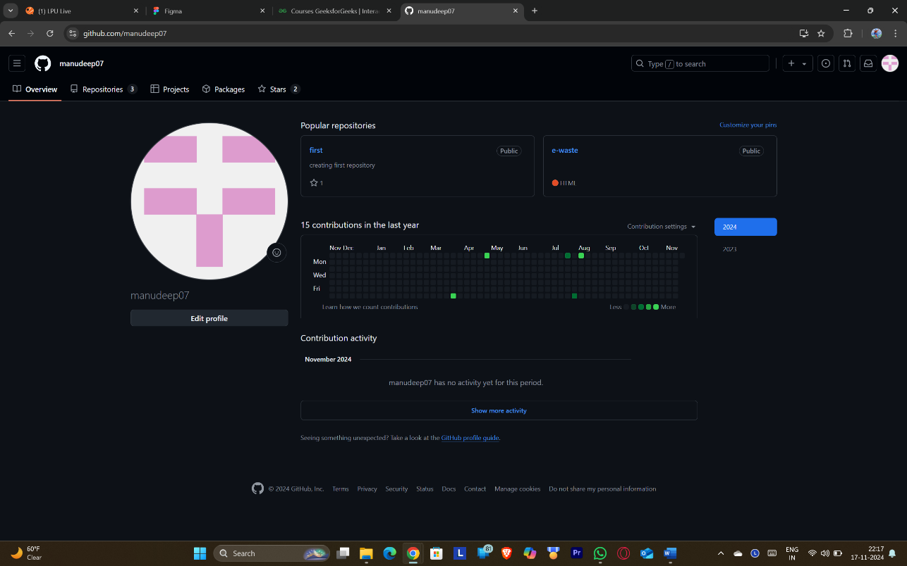**Profile**

My repositories:

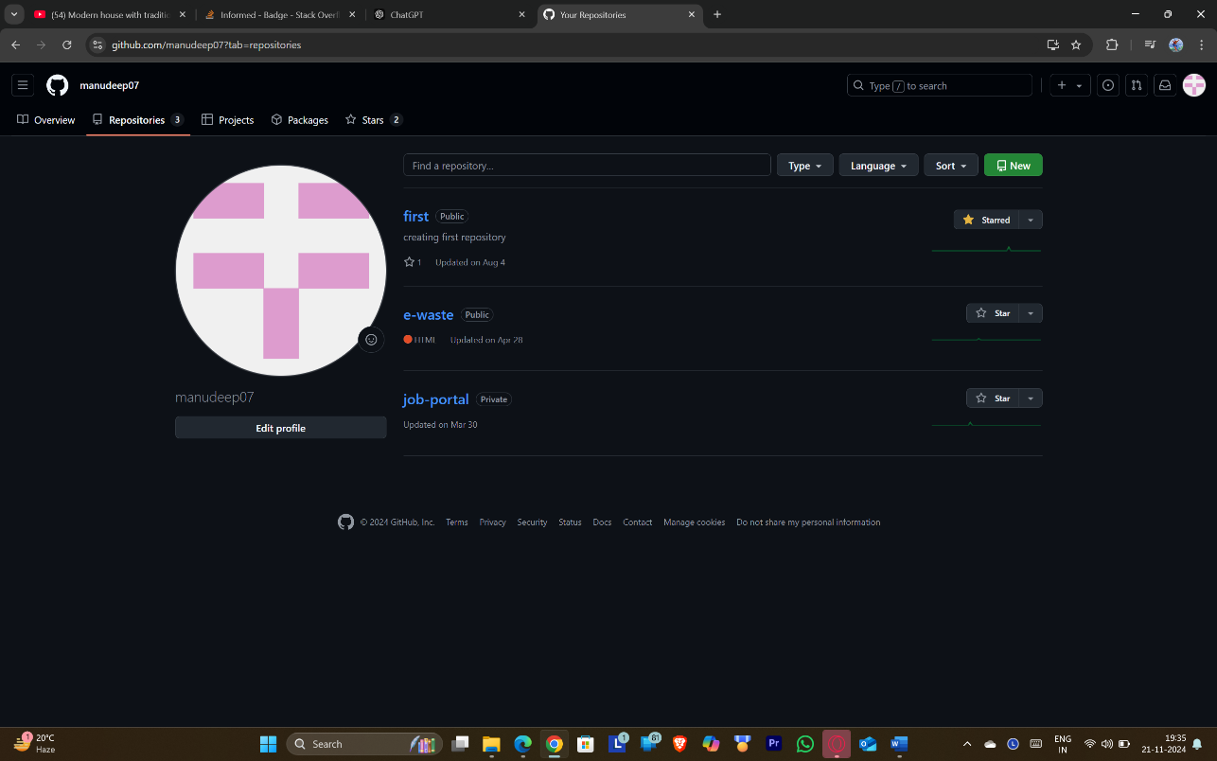

**My forks:**

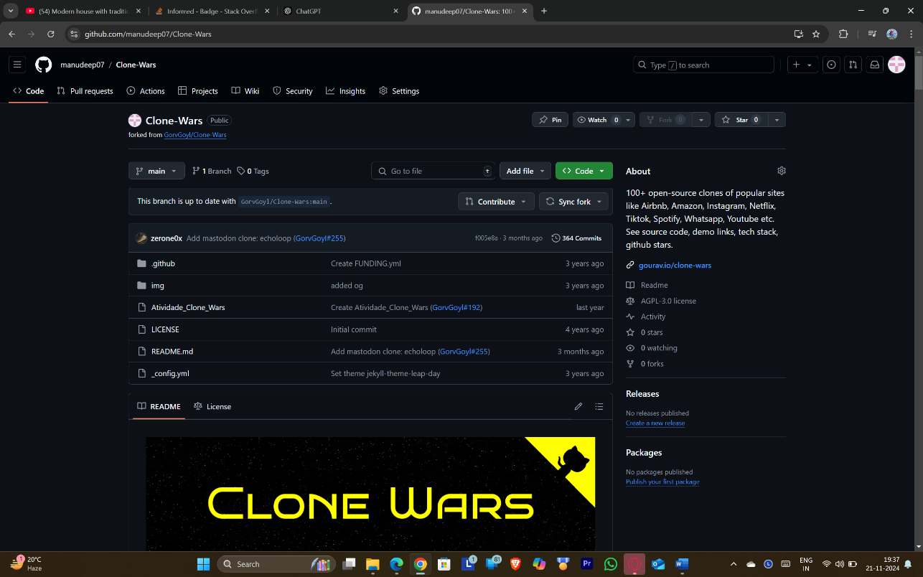

**MOOCS REGISTRATION:**

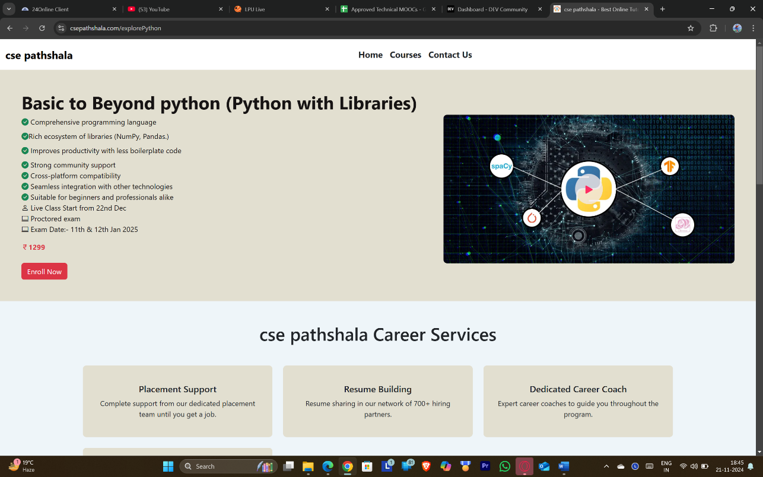

**Registration link:**

**<https://csepathshala.com/explorePython>**

1.

FIGMA

Profile:

Figma internal profile with project

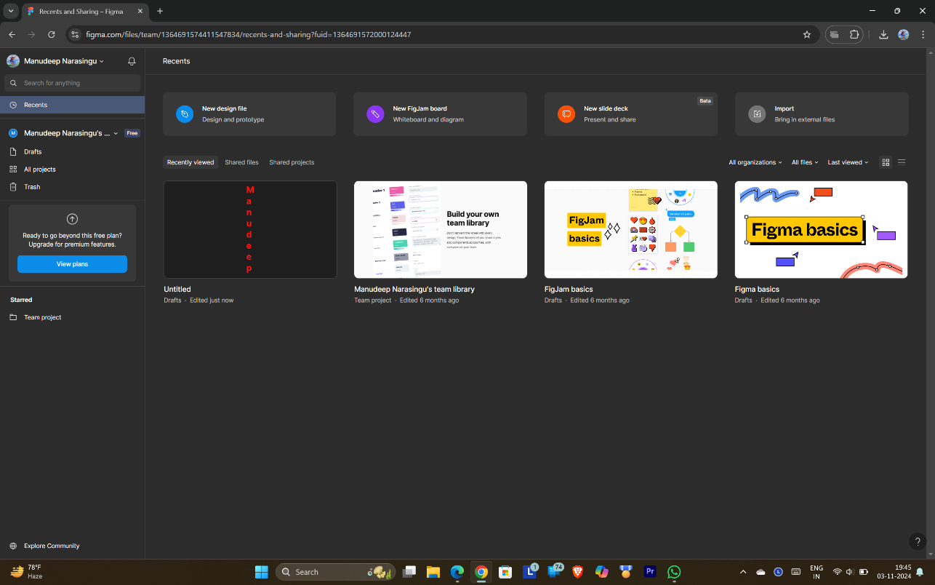

QUORA

PROFILE AND ACCOMPLISHMENT :

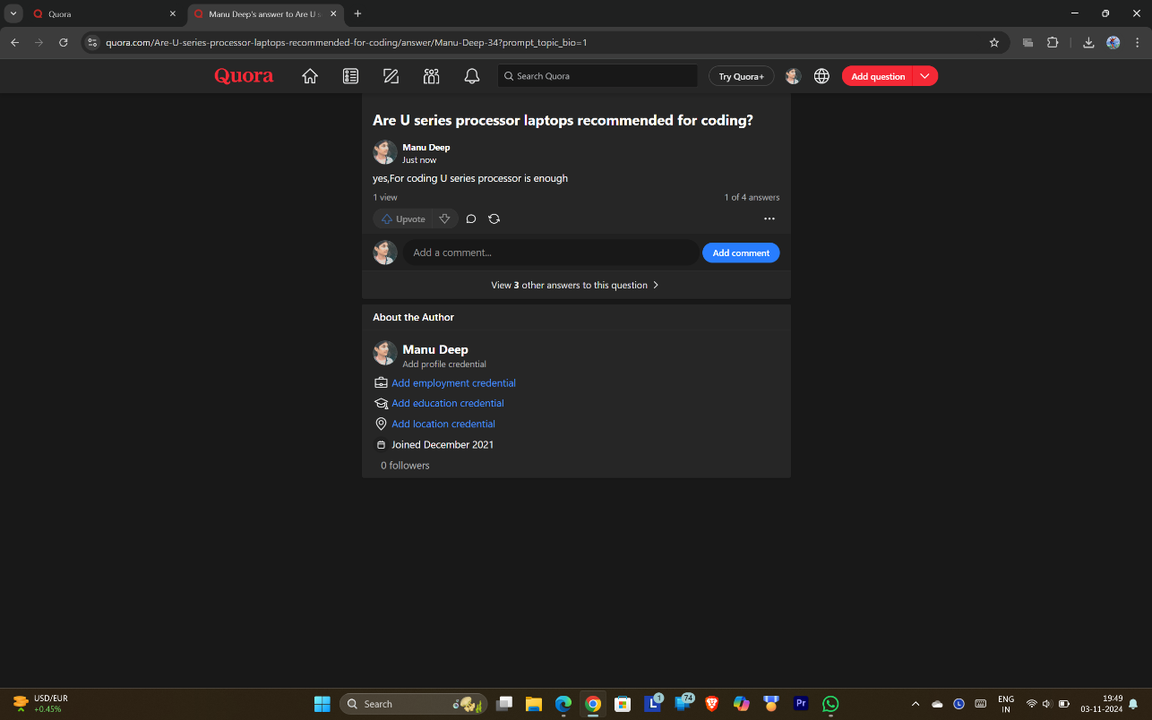

STACKOVERFLOW

PROFILE:

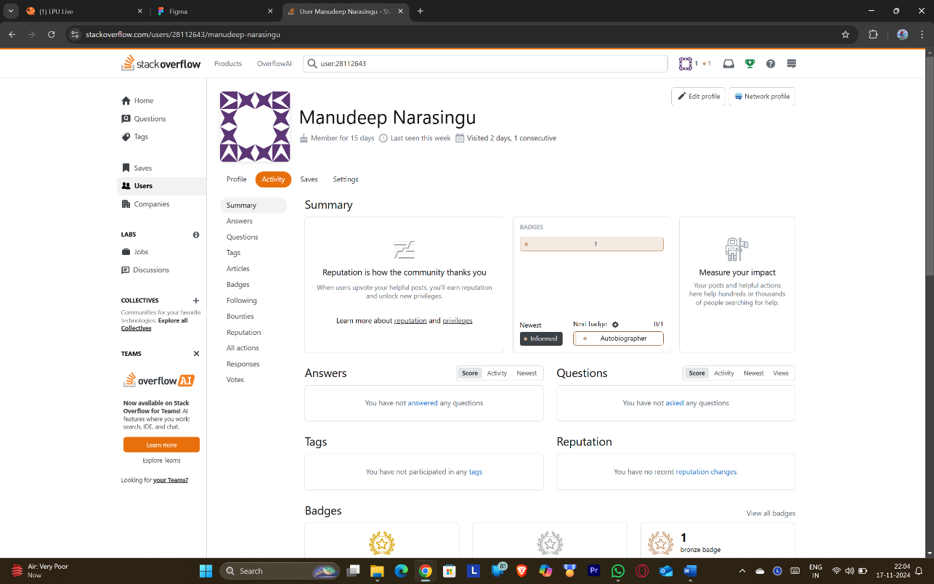

**Accomplishment:**

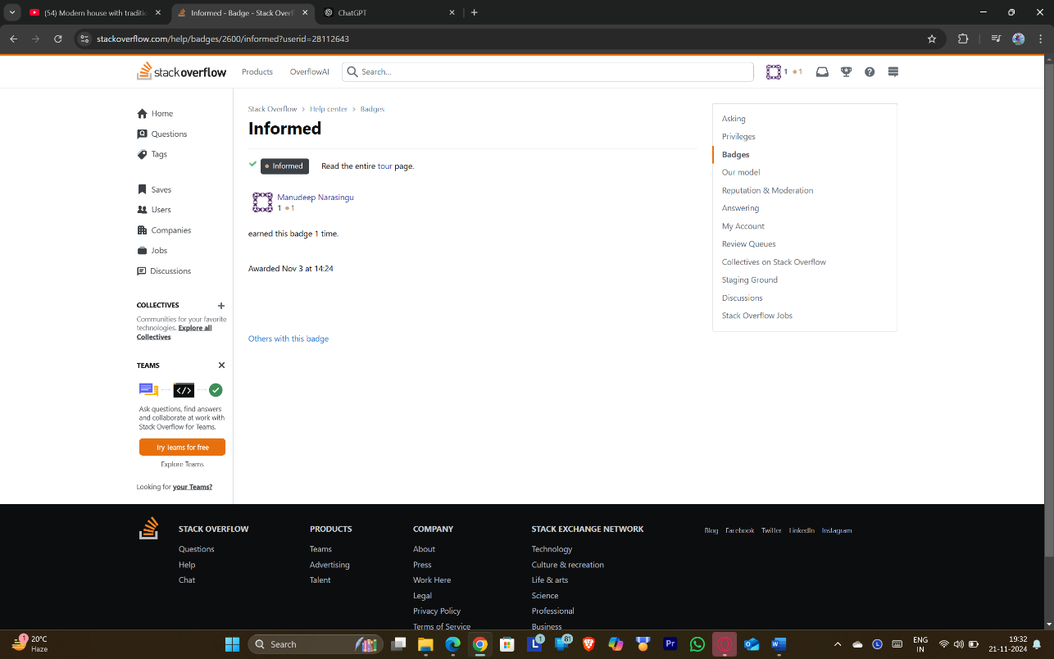

**HACKER RANK**

**Profile:**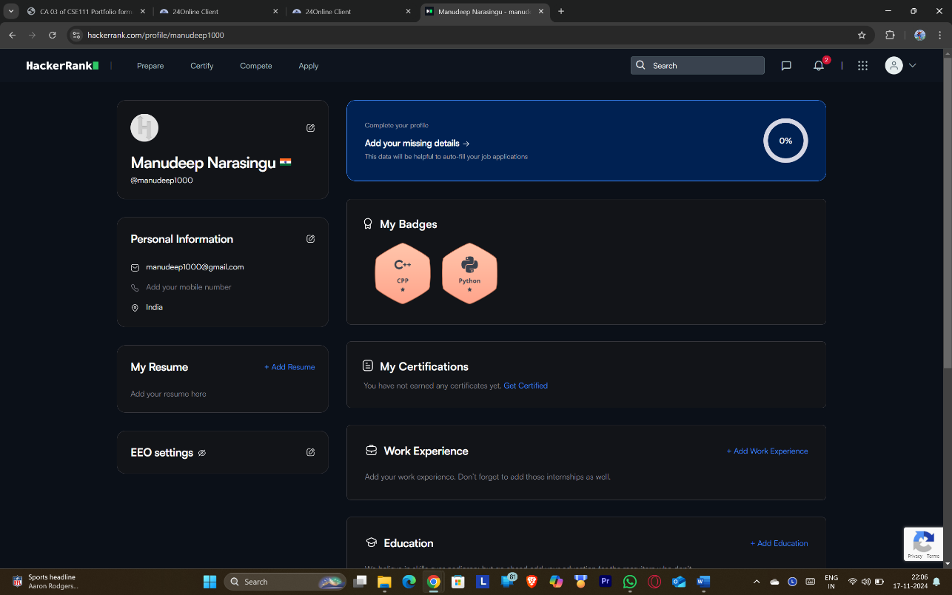

**Accomplishment:**

**Achieved a star badge in python by solving question.**

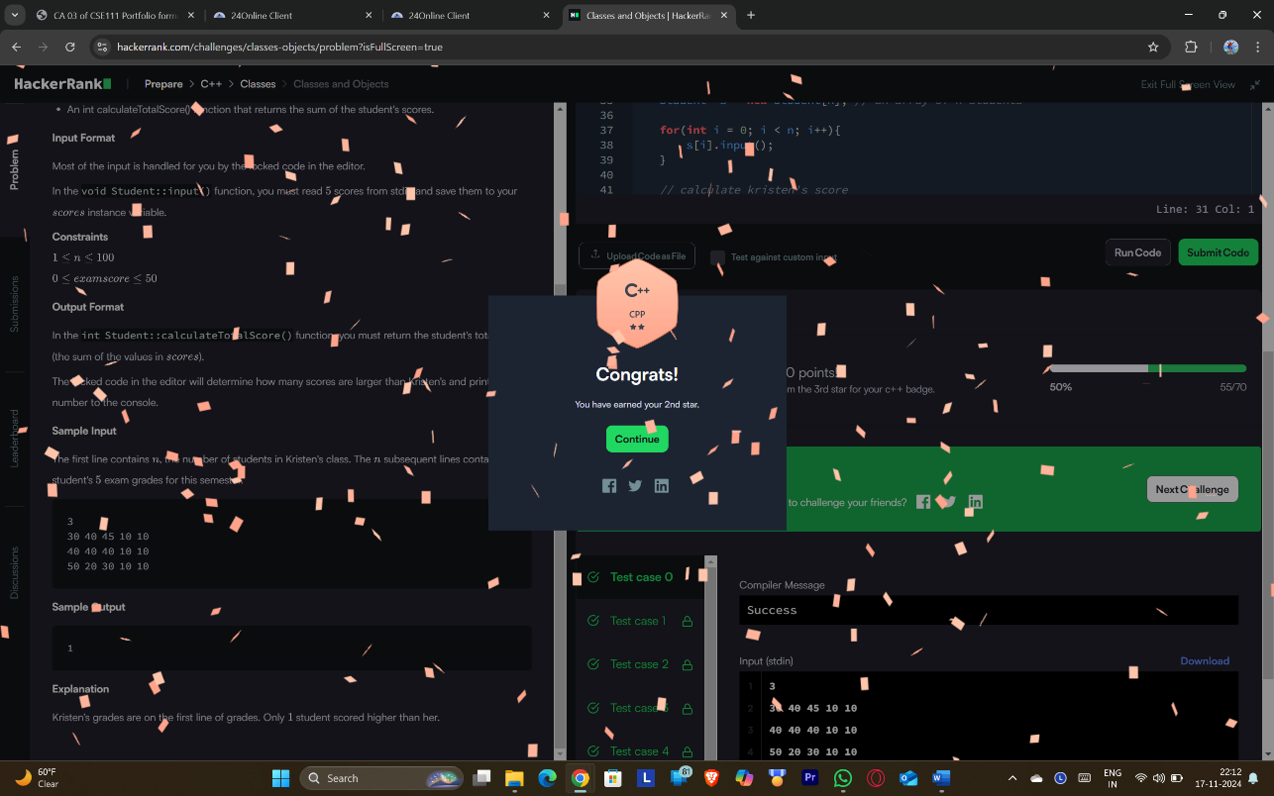

**HACKER EARTH**

**Profile:**

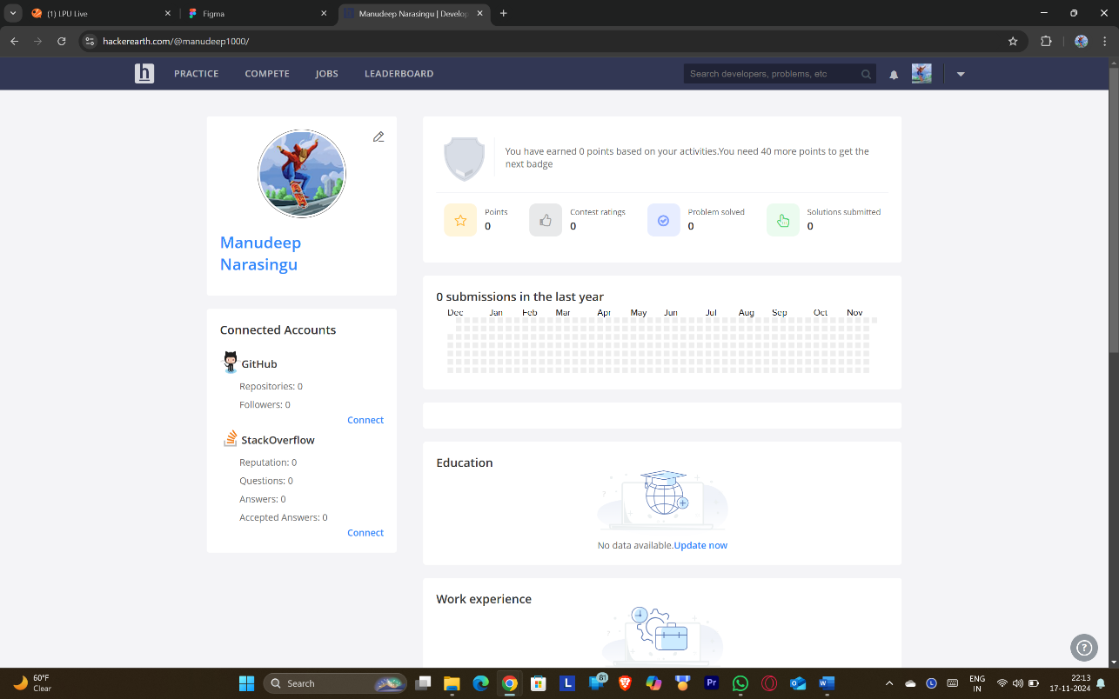

**Accomplishment:**

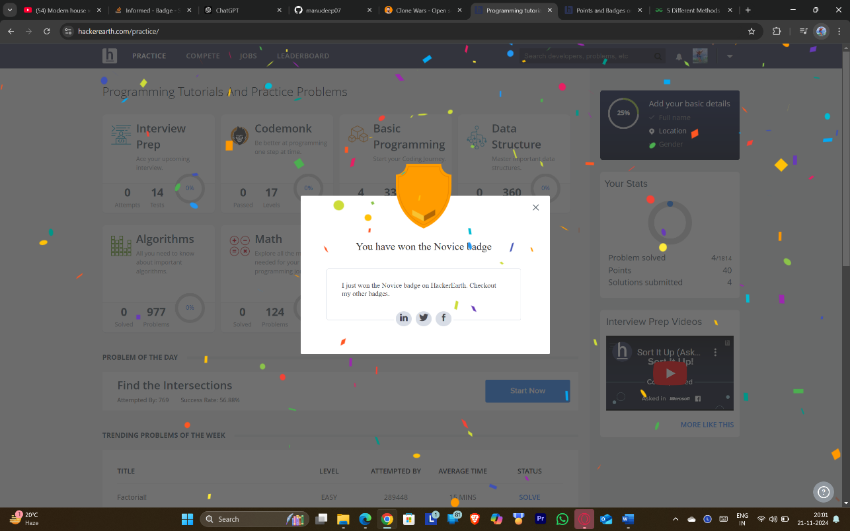

**GEEKS FOR GEEKS**

**Profile:**

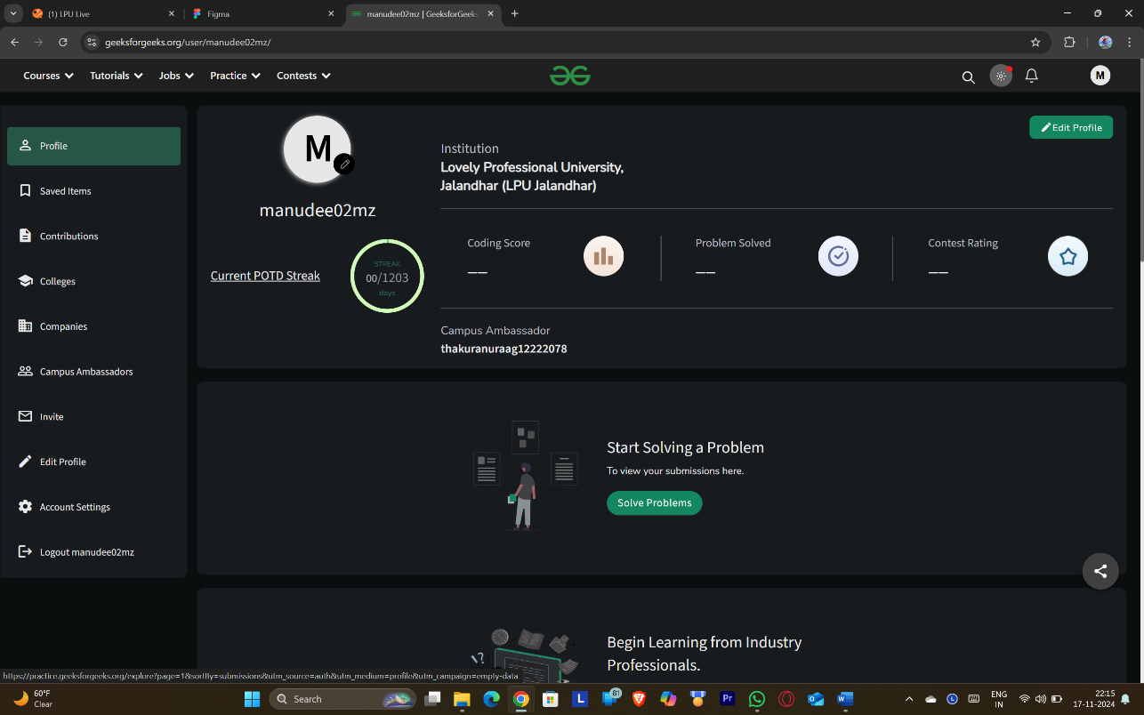

**GIT**

**

Square Space

PROFILE:

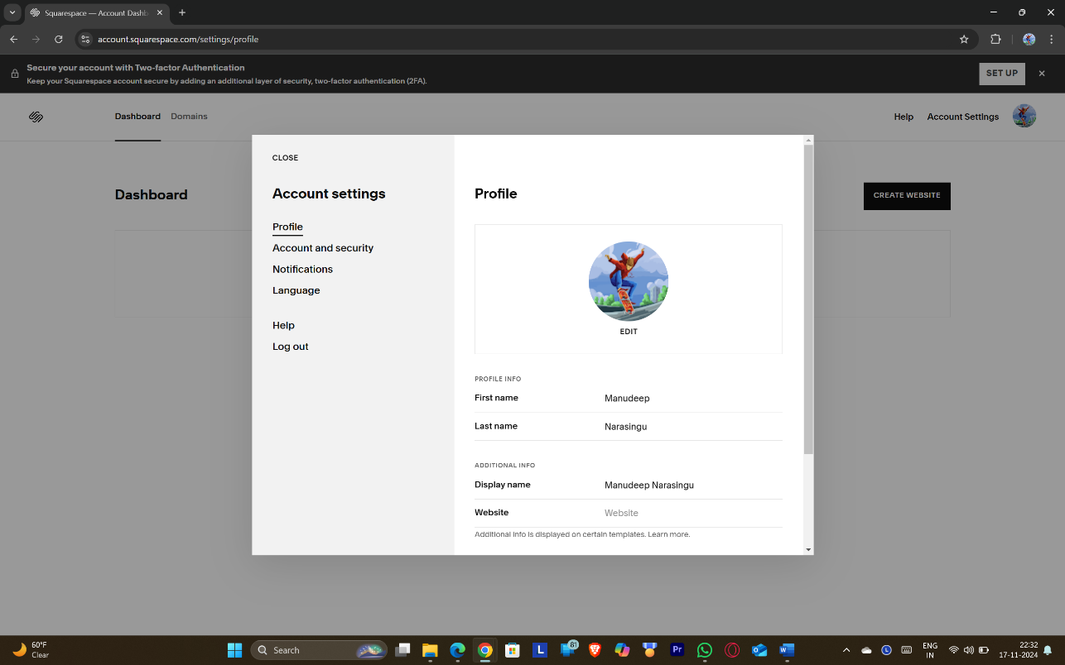

<https://account.squarespace.com/settings/profile>

behance

PROFILE:

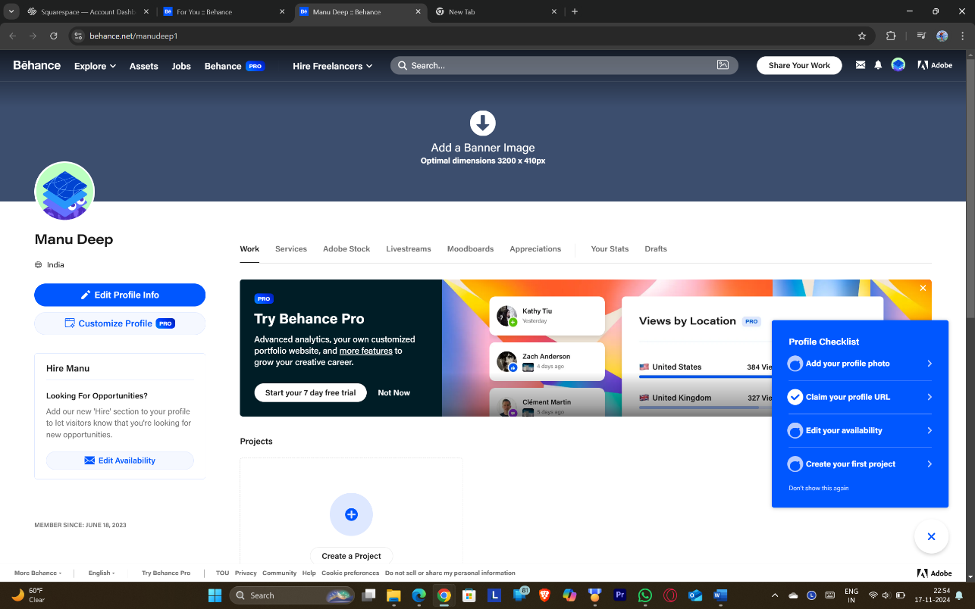

[**https://www.behance.net/manudeep1**](https://www.behance.net/manudeep1)

Adobe

PROFILE:

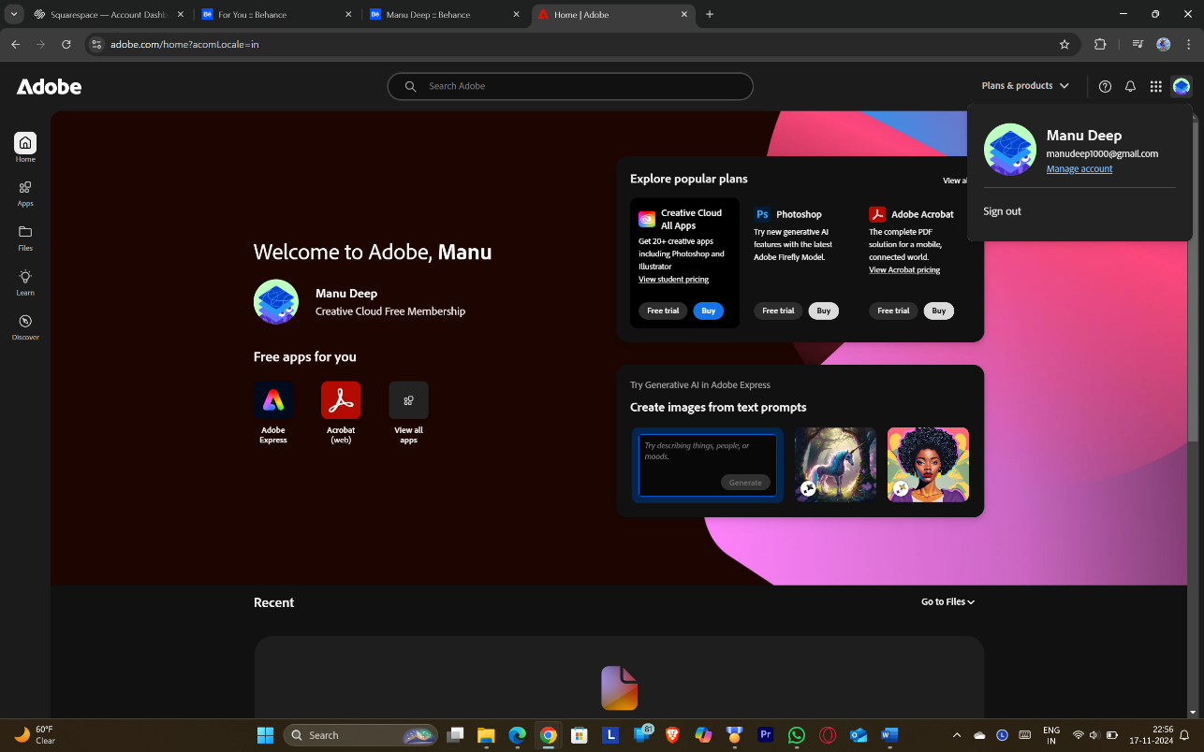

[**https://account.adobe.com/?lang=en**](https://account.adobe.com/?lang=en)

Stock Rover

PROFILE:

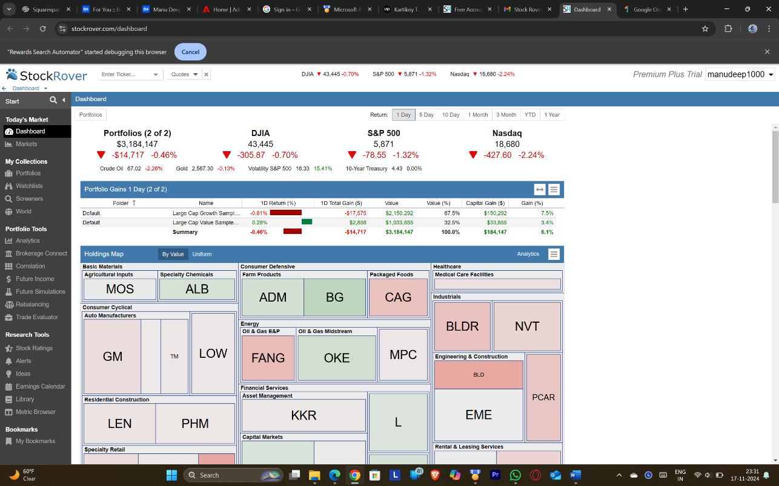

Dev.to

PROFILE:

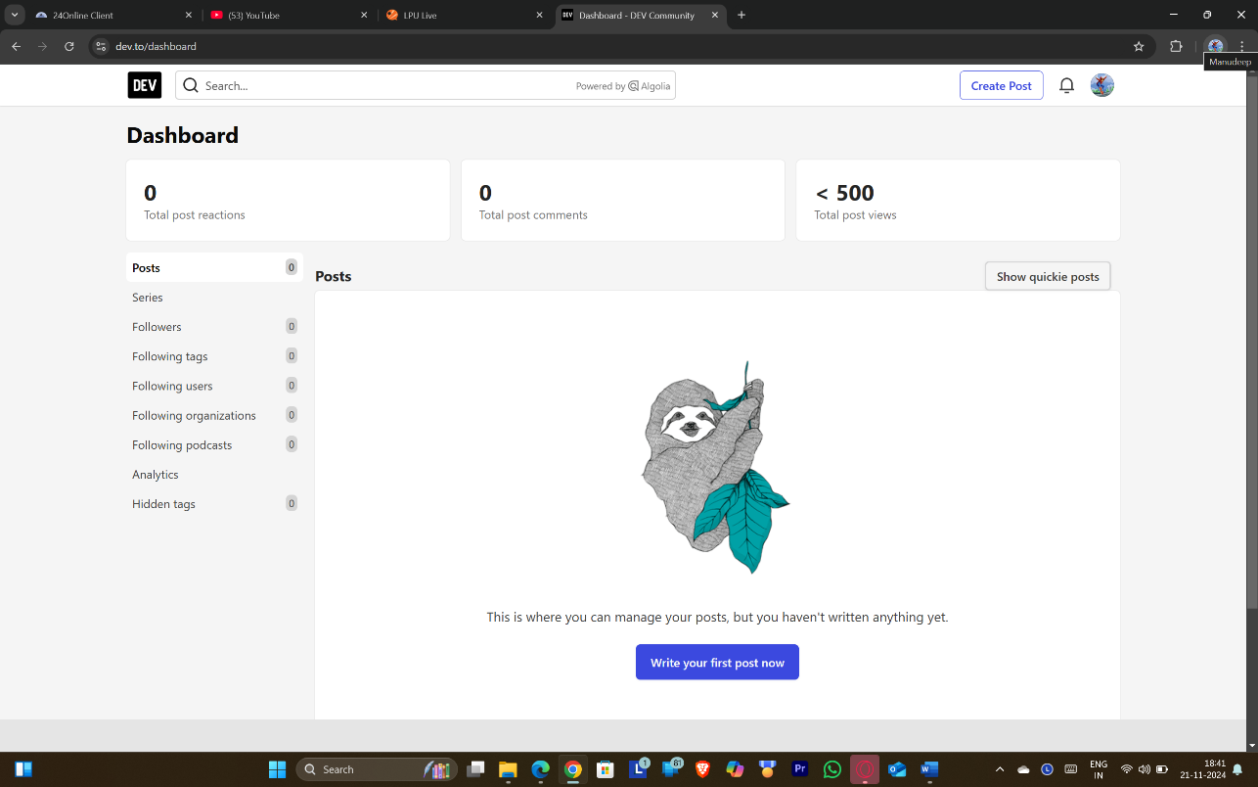

[**https://dev.to/manudeep_narasingu_b6f1af**](https://dev.to/manudeep_narasingu_b6f1af)